Site Description (week 1)

So essentially, Chorus is a transitional site that is used to download songs for a game called Clone Hero, which is a community made version of guitar hero that allows you to play any song that has a chart for it. That includes all the songs from existing guitar hero games, rock band games, and even a whole bunch of charts that have been made by the community themselves.

There are multiple ways to download songs, but my main method is going to a spreadsheet that has been pinned on a reddit post that has all the official song packs. I don’t use Chorus very much, despite the fact that it has nearly 30000 songs added to it, and the design is probably to blame.

It’s been around at least since the start of 2018, while Clone hero has only been around since early 2017, and it’s got pretty simple premise. Players can either search for the song they want or get a random list of songs. If you find what you’re looking for, the yellow words will link you to the google drive file to download it. If you know what you need from the site, that’s all there is to it, but the interface itself is pretty bland and empty, when that space can be filled with other information, tools or graphics

To the target audience, the serious music fans that have played guitar hero for a long time, they might be able to use the service because they know a lot of songs and bands. However, that audience is pretty narrow. For newer players that don’t know exactly what they want, they need to go to the advanced search and search by the song difficulty, genre, artist, etc, or just pick a random song.

The number of ways to narrow your search can be considered a strength, though it is a bit complicated to use, and it may be overwhelming for the new players. The largest weakness is that it is difficult for people to explore content and be able to make a judgement about what they are downloading. They just kinda have to try out random things until they find something good. There’s no built-in way to listen to the song beforehand, or any descriptive album cover to look at, and the DIY background design, where you can link to an image online to make a background seems silly.

My plan to redesign it from the start was to make it easier to find “good” songs with tools such as a likes and downloads count and the option to listen to the song beforehand. Additionally, priority goes to the song packs since players usually download those.

Site Map / Card Sort (week 2)

Given the simple premise of Chorus, downloading either a song or a song setlist of your choosing, the only organization that I really needed to consult the community on was how the songs or packs should be grouped up, as the site is purely content based and there are only two classifications for the content that will be on there. For the cards that were placed in the sorting study, I chose 4 setlists and 6 songs to see how deep other players would want to divvy them up into categories.

As Clone Hero players are one of the only groups of people that know what Chorus is, I consulted the community discord server for polling. Additionally, Clone Hero users closely align with the user demographics of Discord: teenagers and young adults (mostly boys, age 14-24) who live at a very fast pace and would likely want to download everything they need as fast as possible. With mod permission, I posted the link and explained that I was doing a sort for a school project and asked 3 or 4 people to help me out. I ran the test for about an hour and received 5 completed responses.

The average number of categories was 3, as people mostly separated the song packs into two groups and bunched individual songs all together. This highlights one of the issues I mentioned with Chorus, as there is no song pack stash, only individual charts. Song packs can be found by following an external source link at the bottom of each song.

I was not able to ask further, given there are over 130,000 members in the clone hero discord server that filter in and out of activity every minute, as shown by the fact that 10 people entered the sort, but only 5 completed it. Regardless, it seems that respondents sorted songs / packs by their sources (official game or custom), as that was practically the only variable.

As one person made the distinction between most downloaded charts and lesser-known charts, that classification shall be added to the pre-existing search components for individual songs as an option, so people that are willing to dig deeper for songs can have that as a search tool, rather than a whole separate page dedicated to popular songs. I found it unexpected that so few people would add any categorization for the individual songs, as I was thinking that others wanted an easier way to find songs on Chorus as I do.

This translates to four main pages on the site map, custom setlists, game ports, monthly packs (as they are already announced on the site’s banner), and custom songs, which will house every file available for download, rather than linking to Google Drive. It seems that most respondents prioritized pack selections, as the setlists were more often categorized than individual songs, and so they shall be more prominently displayed on the home page as a listing of new pack releases, while those that have more specific searches in mind can go to the filters as a secondary option.

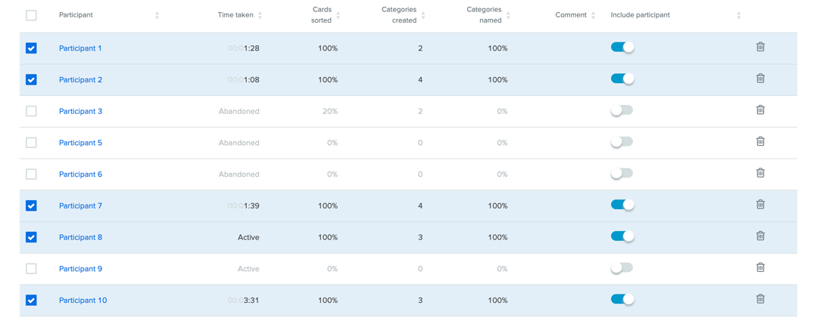
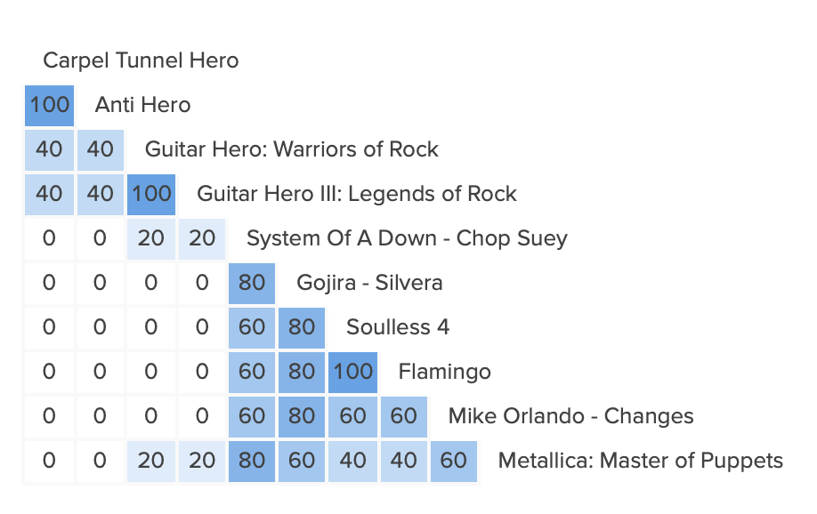

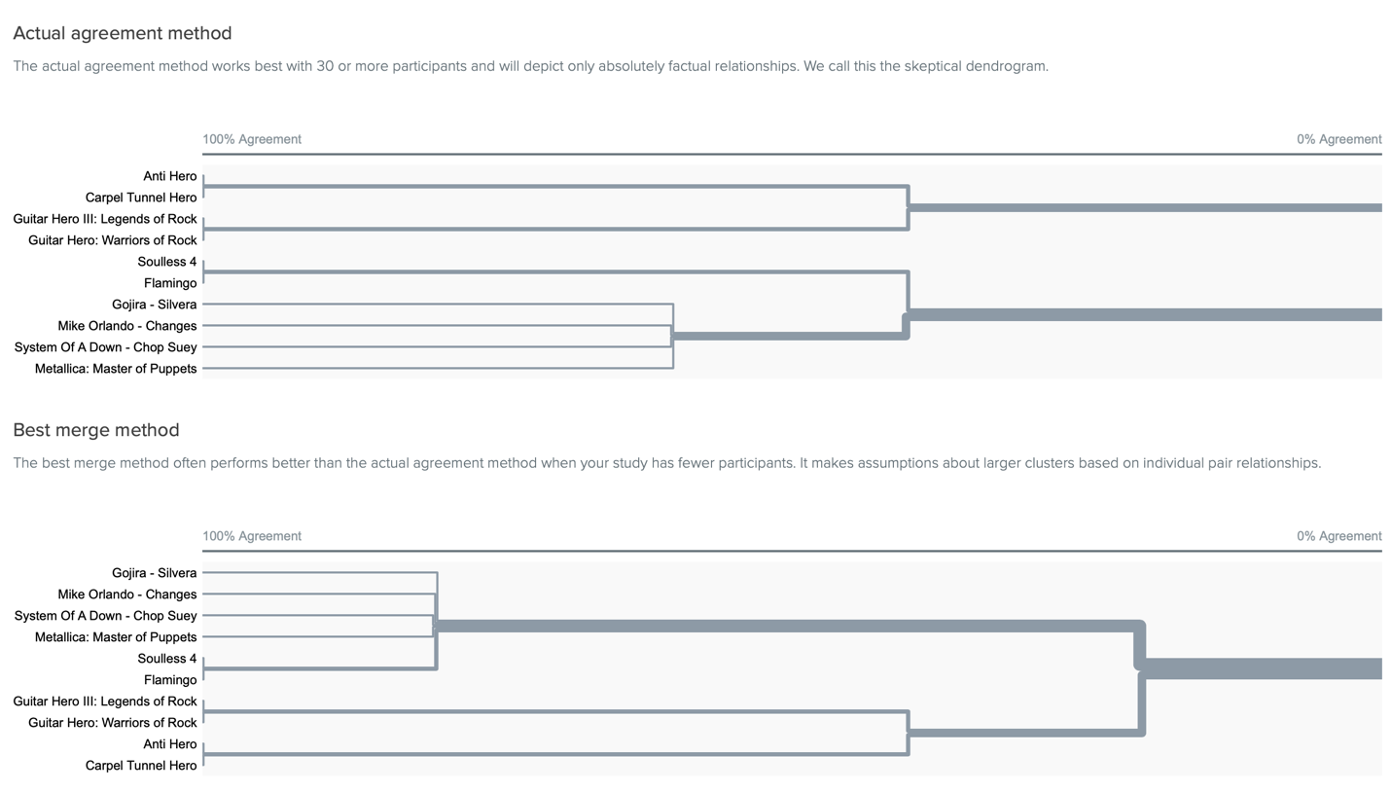

Wireframe / Color / Typography Choices

The wire frame chosen is this one, before final modification took place:
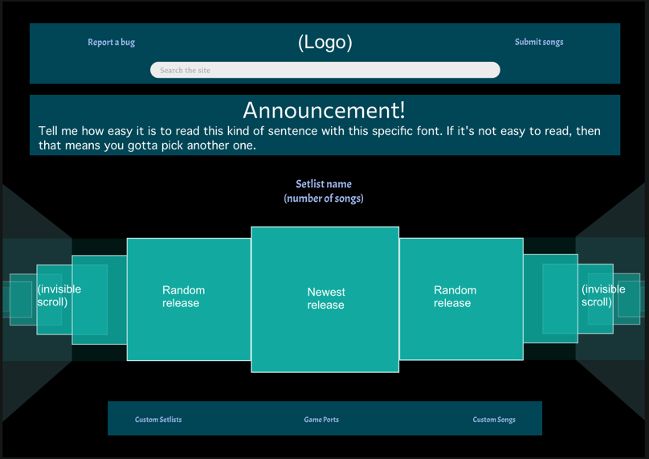
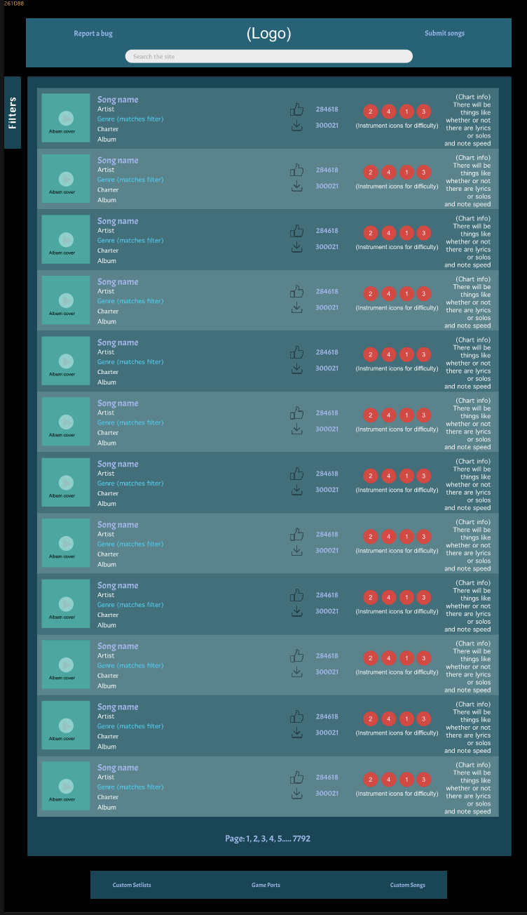

The website opens on a carousel of the song setlists available for download, as there are not too many of them and can be easily navigated beforehand. The descending carousel idea where the pictures get smaller when they are further away stayed through the initial ideation phase, but when it was originally descending on one side, I decided to change it to allow a vertical path for the users’ eyes to follow. The single vanishing side design was not working because it put too much focus away from the selected setlist, along with the original scrolling mechanism which was a numbered box with scroll arrows. Instead, it was replaced with an invisible arrow on both sides of the carousel.
The chart selection page remained similar in structure throughout the refinement process. The initial organization in other wireframes did not work because the filters had offset the song listings, so it appeared to be more cluttered. In the first iteration of the final wire frame, the filters tab was put off to the side to fix this, but it was not visible enough, so future modifications were made to more smoothly implement it.

The color choice was a bit tricky. The other versions I had chosen would be either trying to fit the color scheme of the existing site, trying to fit the color scheme of Clone Hero itself, or something different. Upon reviewing the bluish green and black pallet, I realized that it gives a similar feeling to Spotify which also happens to be a music app that houses all genres of music. As such, I believe the unobtrusive green color accompanied with the black creates an almost neutral feel in regard to a genre connection, as there are a multitude of music genres available to play on Clone Hero, while also being easy on the eyes. It lends well to the images displayed on the site, in the album and setlist covers in particular, as users will click on them to gain access to their content.

On the other hand, the typography lends itself more to genres to “rock out” to, with rigidity in the Staaliches font that was used for headers and navigational buttons. Thonburi is much more applicable in its connection to the game / charts themselves, being used for the setlist titles and download / like counter. DIN alternate in combination with the Staaliches title makes for a complete looking song listing with a big title and supplementary information beneath.

Changes:

From the final selected wireframe, the largest changes were to the interior page. For the exterior page, I replaced “announcement” with “new” and moved it to the left-hand side so not everything was center aligned, preventing the site from looking somewhat empty. I also fixed the header to give most of the priority to the search bar as opposed to the logo, which I put in line with the two side buttons. “search the site” was changed to “What song are we playing today” to be more inviting.

For the interior page, the filter tab was completely redesigned to have an aesthetically pleasing resemblance to the actual song listing, allowing each searchable element on the left side to line up with the actual information of the song directly beneath it. The clear button lays over top of the album cover. The other searchable aspects are spaced out in the filter tab to prevent clutter. The size of the individual song listings was increased for that same reason, and the whole reel of songs also has a vanishing point similar to the entry page where the songs will rise from a “hole” at the bottom of the page when you are at the bottom.

Some of the filter buttons and UI elements were also modified to be more interactive, such as the difficulty slider with the guitar pick handle, the drop-down menu to select the instrument, and the colored buttons for the difficulties included in the chart (easy, medium, hard, expert)

Conclusion:

In conclusion, I believe the current setup is the best it can be without producing clutter, in reference to the filter tab, as the text box has to be big in order to fit long song titles in a space with less room than the actual song listing. If that were not an issue, I would move the other filter elements over to line up with the actual listing. Otherwise, the color scheme that highlights the content itself is majorly effective. The playlist style display of songs and the reel of setlists looking like disks in a karaoke machine also help to fit the musical connection this site has to its musical game. The new filters tab provides a much simpler method of searching than the previous filter page as users can look in the same spot to input information as they would to actually look at a song listing. Prominently displaying the album covers (and playing the song) allows users to have more of an understanding of what they are downloading before they download it, which is crucial since chart and setlist downloads are all this site is needed for. With these modifications to the searching and selection system, users can have a more pleasant and informed experience when looking for their next song to jam out to.

